Mobile Technology 11492 Final Assignment

University of Canberra Semester 1, 2020

Leonard Tkatchenko (u3205216)

# Task 4

**Error 1:** ‘Cannot resolve symbol ‘Bundle’ (Missing import: android.os.Bundle) in MainActivity and SecondActivity

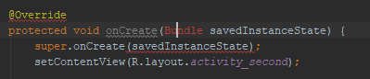

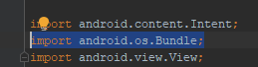

**Error 2:** ‘Cannot resolve symbol ‘TextView’ (Missing import: android.widget.TextView )





**Error 3:** Spelling error in acitivty_main.xml (onClick)



Fixed by changing to clickMe



**Error 4** spelling error in secondActivity





From Main Activity:



**Error 5**: Missing ID in activity_second.xml TextView widget

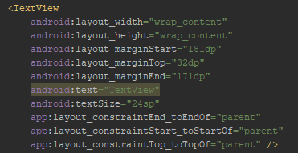

Fixed by adding ID:



# Task 5

Activity 1:

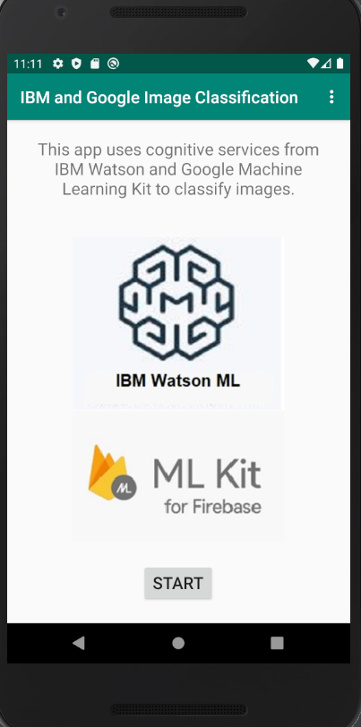

Activity 2:

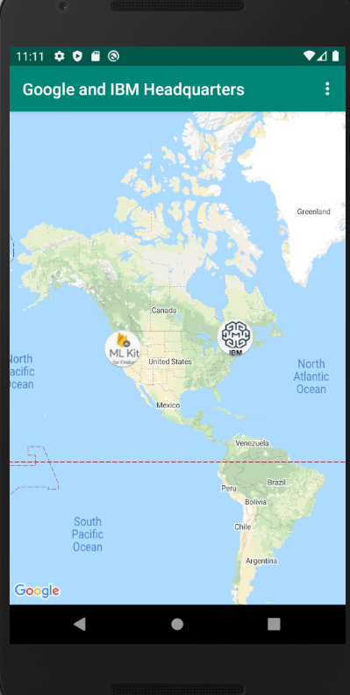

Activity 3 (Google):

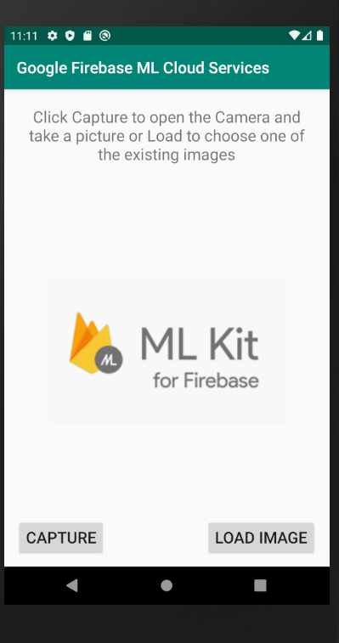

Activity 3 (IBM):

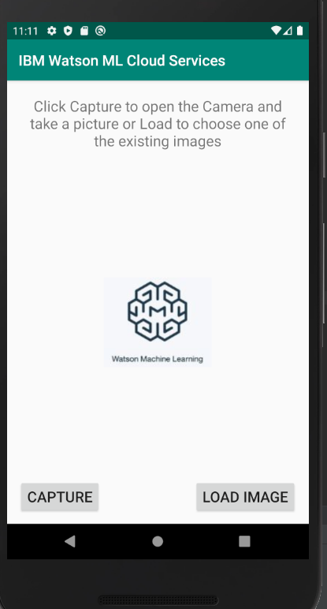

Activity 4:

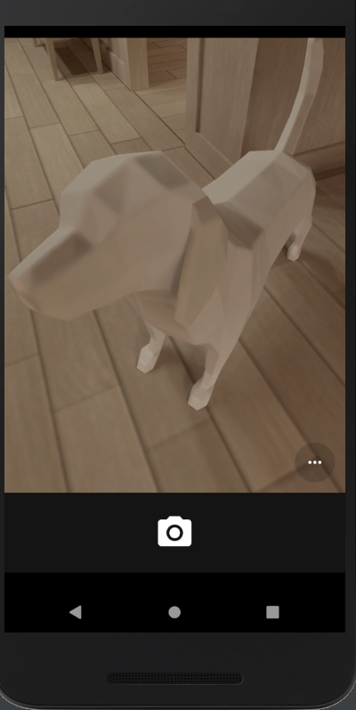

Activity 5:

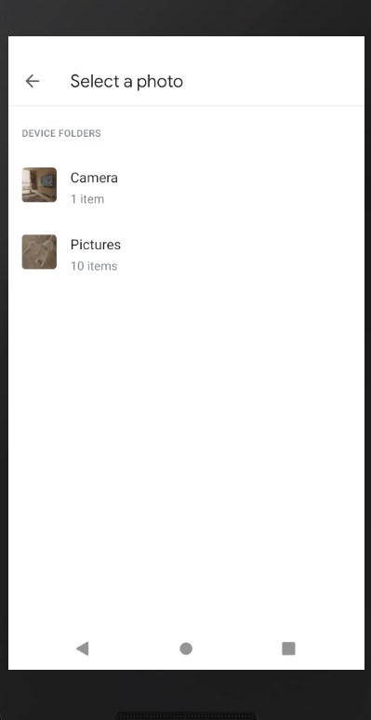

Activity 6(Google):

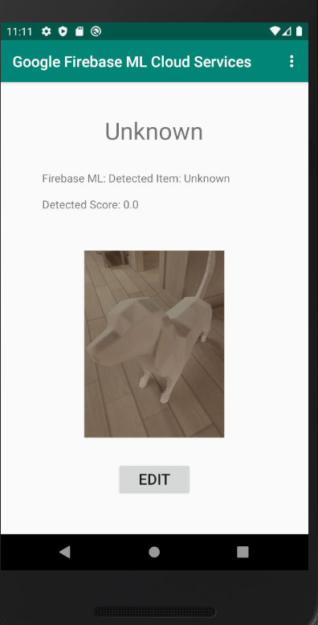

Activity 6(IBM):

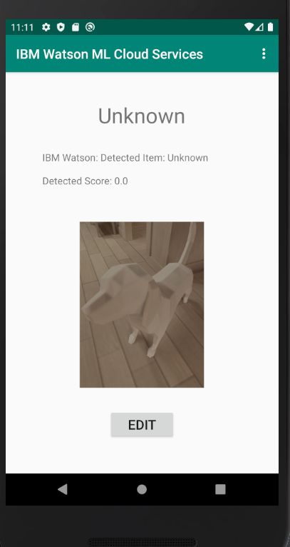

Activity 7 (Google):

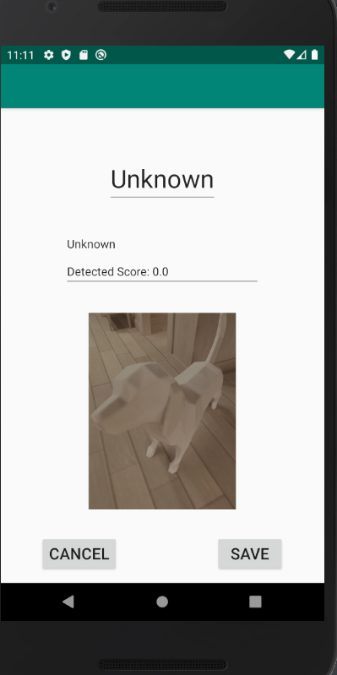

Activity 7 (IBM):

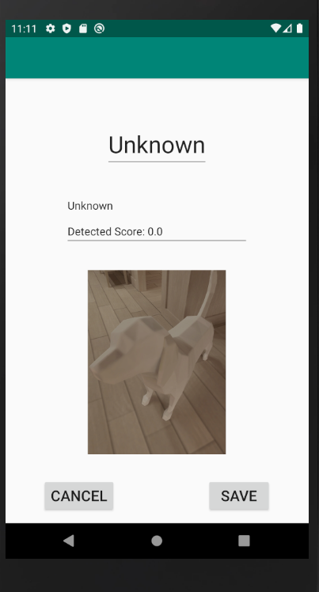

Activity 8:

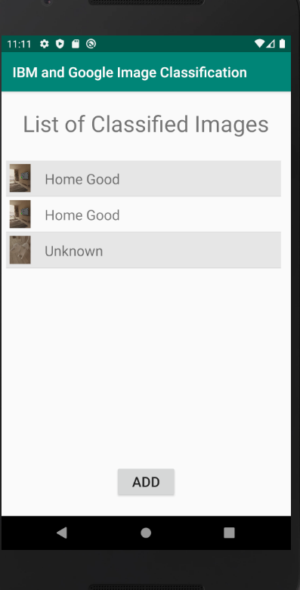

Activity 9:

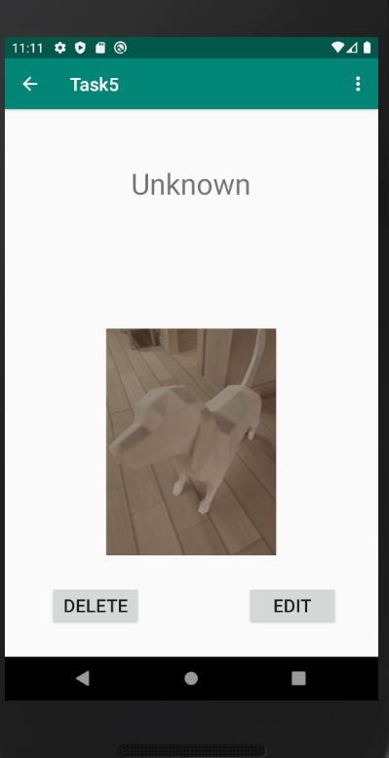

Firebase Storage:

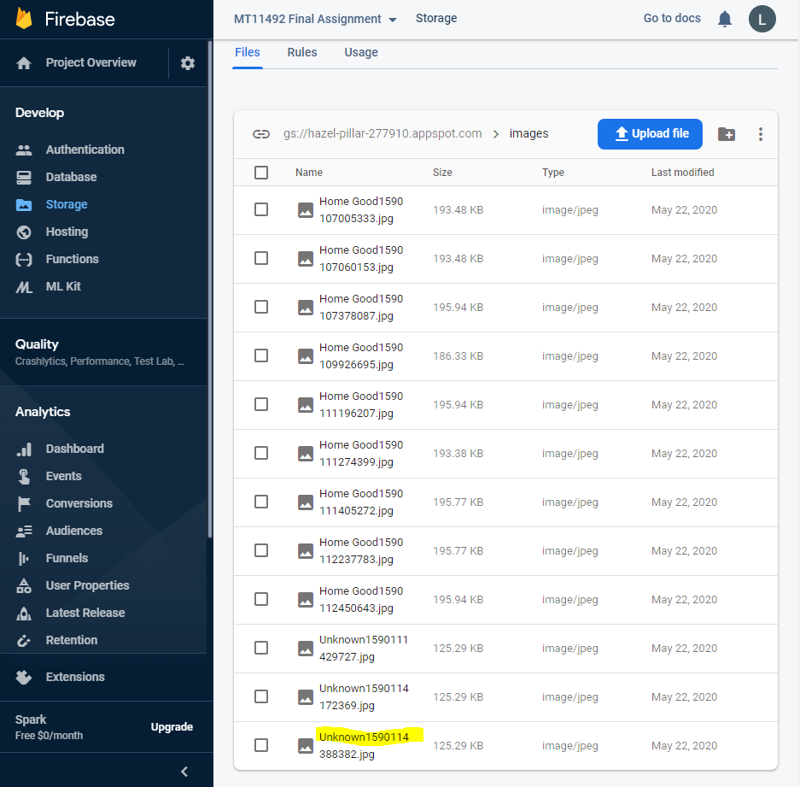

Firebase Database:

